Anneka Lenssen

280 words

**Bachi, Marwan Kassab (1934--)**

Born in Damascus, the Syrian painter Marwan Kassab Bachi, who often goes by only the name Marwan, began his career in Damascus before emigrating to Germany, where he became a Professor at the Hochschule der Künste in Berlin in 1980. Marwan’s earliest works in the mid-1950s followed a modern Symbolist style inflected by folk motifs. After leaving Syria in 1957 to study painting in Berlin, he joined the studio of Hann Trier and became aligned with Germany’s postwar New Figuration movement. The subjects of his painting series in the 1960s included politicians in clamps and braces, piles of fleshy meat, and melancholy figures with elongated bodies and distorted heads. Marwan’s later work emphasises colour and texture over legibility and in recent years, his paintings of monumental heads take form through layered fields of brushmarks that verge on abstraction. Because of the repetitious and self-effacing aspect of these compositions, they can also be interpreted as explorations of Sufist principles. Marwan maintained close ties to Arab modernist movements in art and literature for the whole of his career, and contributed drawings and sketches to the publications of friends such as the poet Adonis, the novelist Abdurrahman Munif, among others.

**References and further reading**

Atassi, Mouna, and Samir Sayegh (1998) *Contemporary Art in Syria, 1898-1998*, Damascus, Syria: Gallery Atassi. (Contributor’s comment: Most comprehensively illustrated volume on modern Syrian art).

Institut du Monde Arabe (1993) *Marwan: Peintures, Gravures,* Paris:Institut du Monde Arabe. (Contributor’s comment: exhibition catalog).

Munīf, ʻAbd al-Raḥmān (1996) *Marwan Qassab Bashi: Riḥlat al-˘ayāt wa-l-Fann (Marwan Kassab Bachi: Art and Life’s Journey),* Damascus, Syria: Muʼassasat al-ṣāliḥī. (Contributor’s comment: A detailed account of Marwan’s life and work by respected author Abdurrahman Munif, a close friend of the artist).

**Paratextual material**

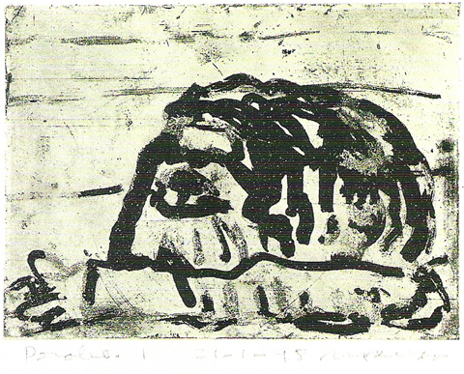

Marwan Kassab Bachi, *Faces/Ibn Arabi* (from a series of 99 etchings), 1997/1998, etching, 22x16 cm.

Source and copyright: The Khalid Shoman Private Collection, Amman, Jordan